Bracknell School Nursing Team
The Rowans & Sycamores Children’s Centre
Pondmoor Road
Bracknell
RG12 7JZ
Telephone: 0300 365 6000
Email: Bracknellforest.SN@berkshire.nhs.uk

September 2025
SCHOOL NURSING SERVICE
NATIONAL CHILD MEASUREMENT PROGRAMME

Dear Parent / Carer
Height and weight checks for children in year 6
Every year in England, children in Reception and Year 6 are weighed and measured as part of the National Child Measurement Programme (NCMP). Full details of the NCMP can be found by following this link: https://www.nhs.uk/live-well/healthy-weight/national-child-measurement-programme
As part of the programme, your child’s name, date of birth, sex, address, postcode, ethnicity and NHS number will be provided by your local authority. Your child’s class will take part in this year’s programme; the date of the screening will be available from your child’s school.
This short video explains how the programme is delivered in Berkshire NCMP process (please note Year 6 parents will only receive a letter if their child falls outside of the healthy weight range).
The measurements will be carried out by trained staff from your local school nursing team in a private area in your child’s school. Children will be asked to remove their shoes and coats and will be weighed in their indoor clothing. The programme will be delivered in a safe way, following government advice that aligns with national and local guidance for schools and infection control.

Maintaining the well-being of children in the NCMP
The wellbeing of children and families is very important. Measurements are conducted in a sensitive way, in private and away from other children. All information and results will be treated confidentially. Your child’s height and weight results will not be shared with your child, other children or school staff. These results will be entered onto your child’s electronic health record. The NHS Digital database (NCMP) will place your child’s height and weight into one of the following ranges – ‘underweight’, ‘healthy weight’, ‘overweight’ and ‘very overweight’. If your child is outside of the ‘healthy weight’ range you will receive a letter by post with further information.

Cont/-

In summary, the programme is led by Berkshire NHS Trust, with support from schools by:
- sending the enclosed letters to parents and carers to inform them about the NCMP – we will provide the letter to give to pupils or to be sent by email directly to parents.
- identifying any children who are unable to participate because of disability, medical condition or other reason.
- providing class lists of Reception and Year 6 pupils, including dates of birth, ethnicity and NHS numbers. (NB. Ethnicity and NHS Number are new requirements)
- identifying a suitable room or area away from ambient noise, where the measurements and hearing* and vision* screening (*for Reception children only) can be undertaken privately.
- arranging for school staff to bring children to and from the screening area.

We would be most grateful for your support and co-operation as we undertake the programme over the coming months.
If you require any further information, please do not hesitate to contact us on the above number.

Yours faithfully,

The School Nursing team

The emotional impact of the NCMP has been researched and studies show that body image, self-esteem, weight-related teasing and restrictive eating behaviours do not change as a result of being measured or receiving feedback. If you are concerned about your child’s growth, weight, body image or eating patterns, seek further support from a school nurse or General Practitioner.
The NHS Digital database (NCMP) provides information to help build an understanding of national and local trends in child weight. It is important to have a good understanding of how children are growing, so that the best possible advice and support can be provided for them and their families.

The information we collect and what it is used for is listed below:

The information collected about your child will also be shared by NHS Digital with Public Health England but in a de-personalised form only. This means Public Health England will not be able to identify your child. Public Health England is responsible for working to protect and improve the nation’s health.
Local authorities have a legal duty to collect the NCMP data. They do this by following guidance from the Office for Health Improvement and Disparities part of the Department of Health and Social Care (DHSC).

The diagram below displays what happens to your child’s data as part of the NCMP.
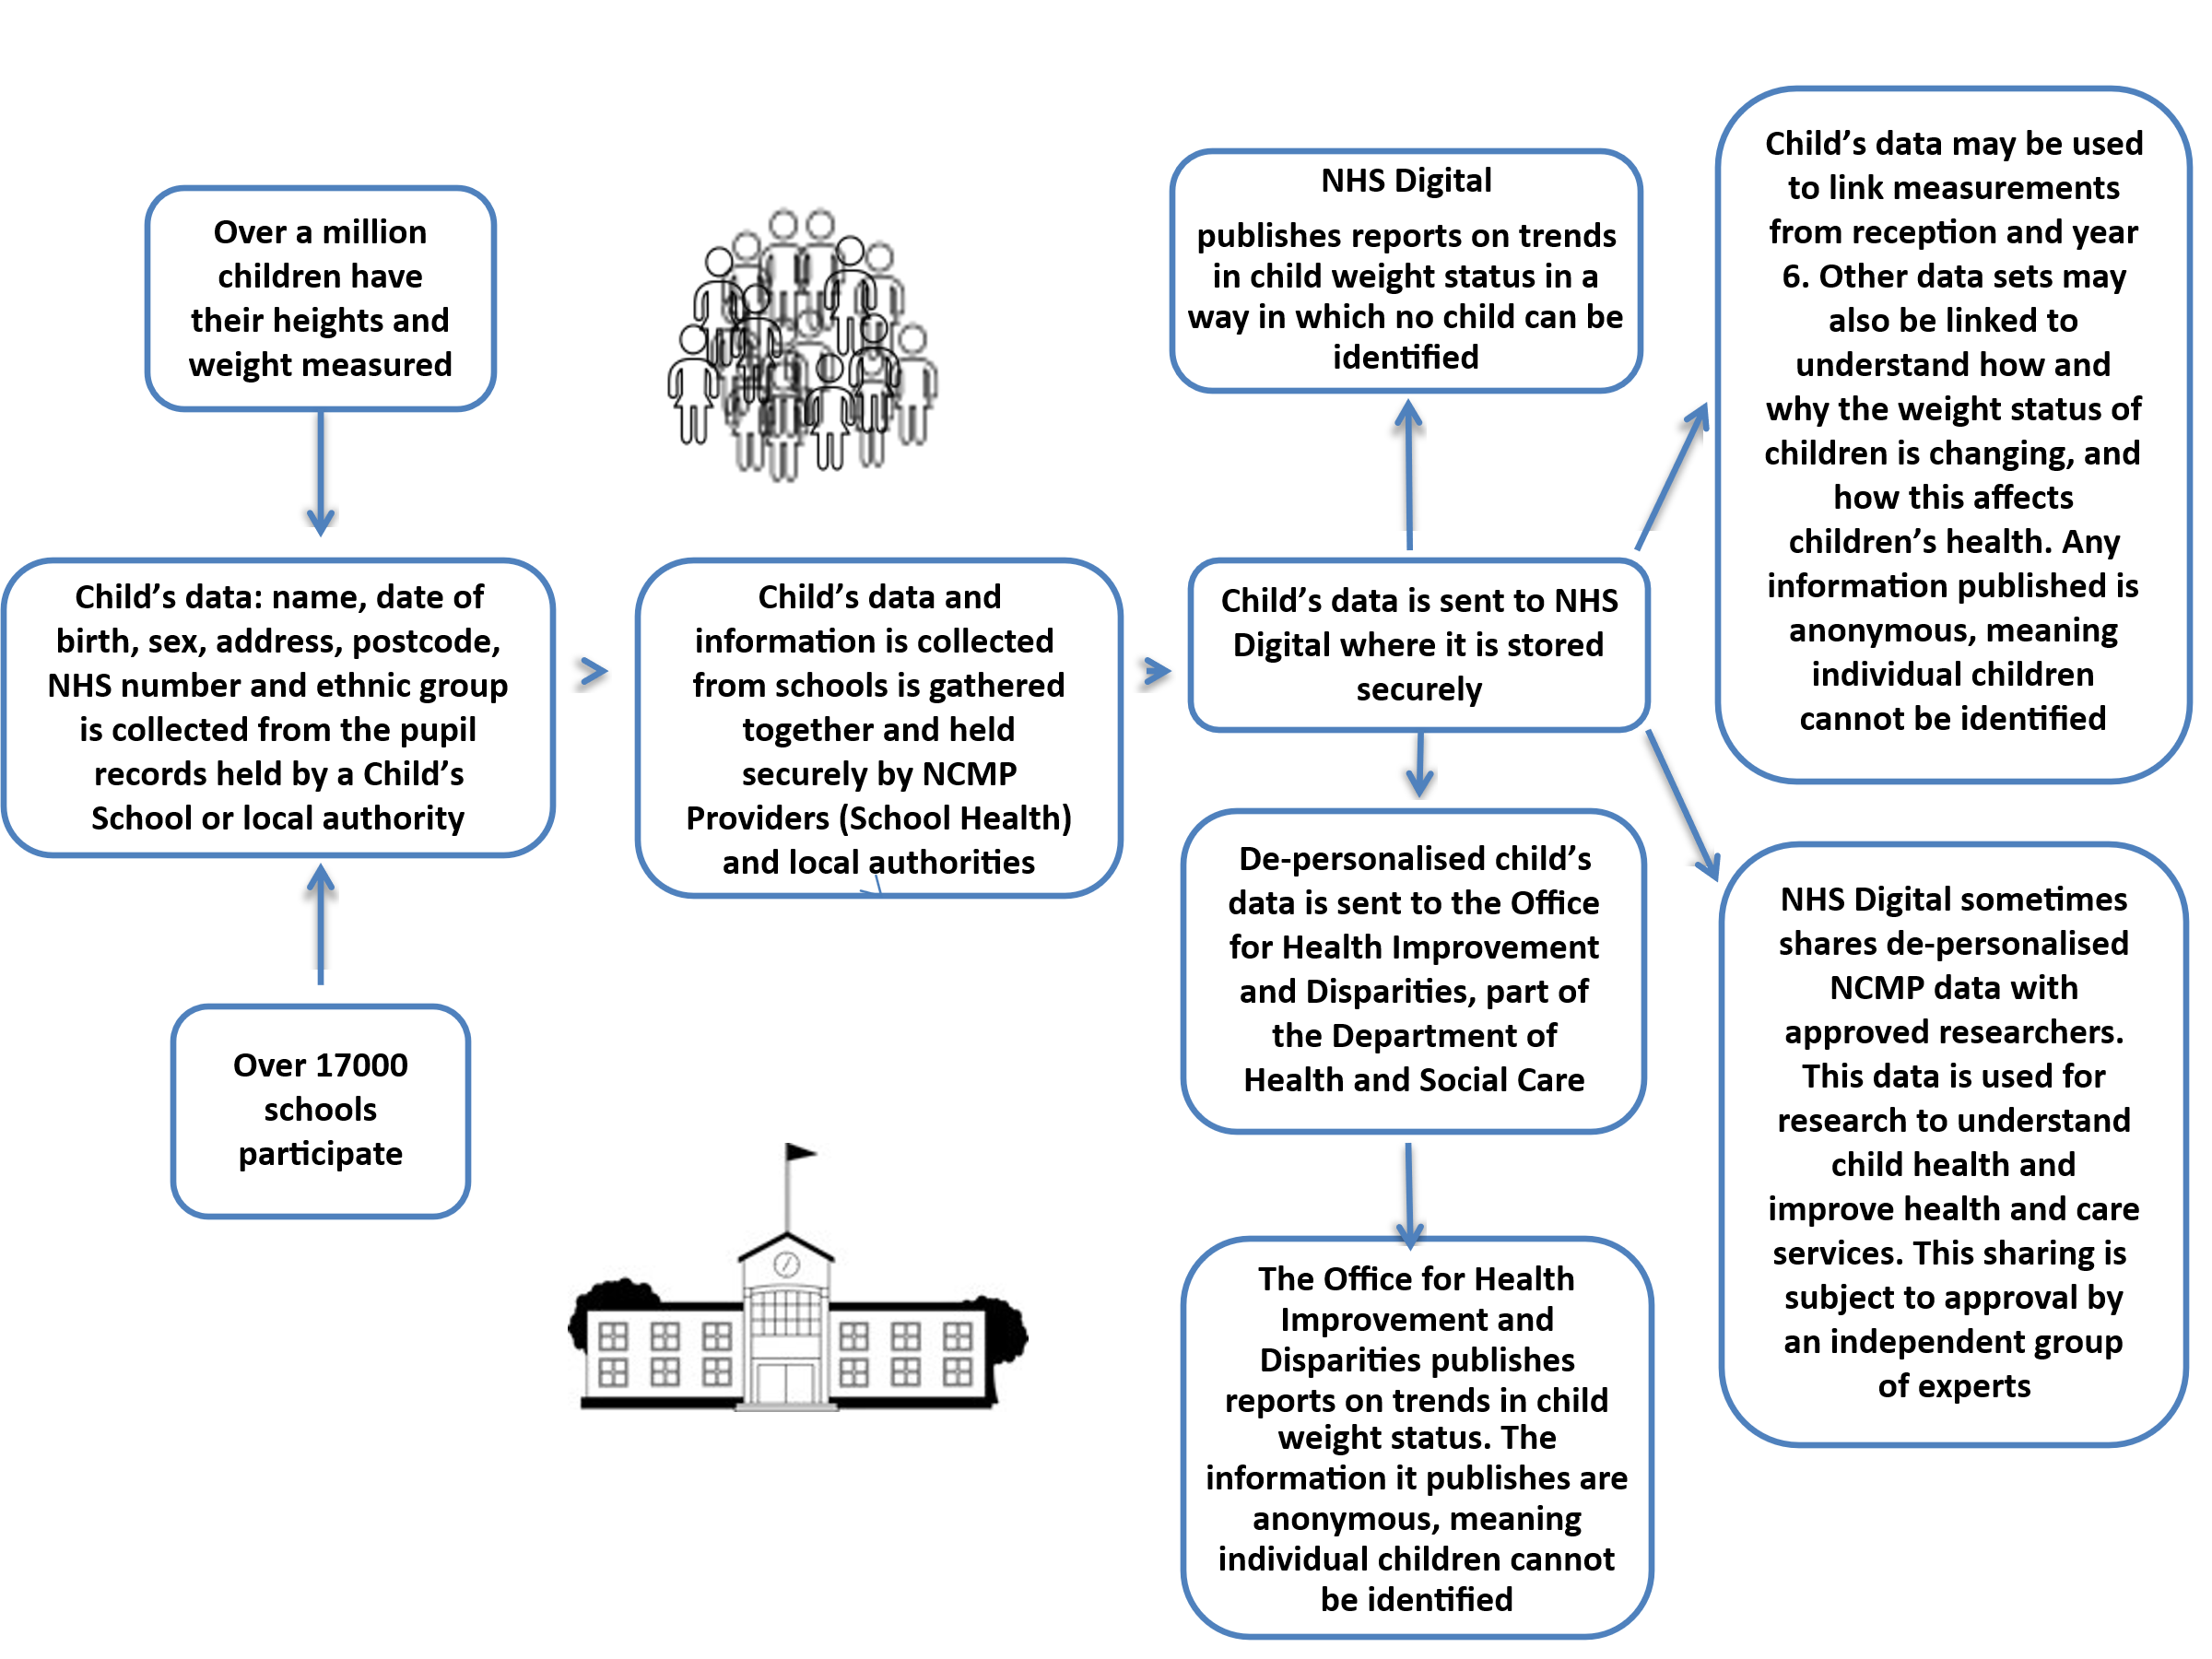

Opting your child out of the programme

If you are happy for your child to be measured, you do not need to do anything.
If you do not want your child to take part, or your child has a medical condition that affects their height or weight, or if you have any questions, please inform your school nursing team by emailing bracknellforest.SN@berkshire.nhs.uk within seven days of receipt of this letter. Please clearly state your child’s name, school and date of birth.
Children will not be made to take part on the day if they do not want to.
Please note if your child is absent or opts out on the day we attend school we do not return to complete the measurements.
Further information and advice
You may be interested to know that Berkshire Healthcare has produced child health information on the Berkshire Healthcare NHS Foundation Trust website: www.cypf.berkshirehealthcare.nhs.uk This is an on-line resource for parents, carers and school staff offering advice sheets and information on child development.
Information and fun ideas to help your kids stay healthy can be found at
https://www.nhs.uk/healthier-families/

Another way to help maintain a balanced diet and physical activity for your family is the NHS Healthy Steps email programme. Sign up for the 8-week Healthy Steps emails and you will be sent lots of low-cost easy tips, fun games, healthy swaps and tasty recipes on a budget, visit healthysteps.uk to sign up.
Are your child’s immunisations up to date?
To check the current vaccine schedule visit: www.nhs.uk/conditions/vaccinations For any missing immunisations, please contact our school aged immunisation team via email at Eastschoolimms@berkshire.nhs.uk or phone them on 0300 365 0077 and they will be happy to help.

You can read more about how the Department of Health and Social Care collects, stores and uses your child’s information and data in the National Child Measurement Programme: privacy notice

Information about how NHS Digital and Public Health England collect and use information can be found at National Child Measurement Programme (NCMP): GDPR information

Your school nursing team is here to support you and your child. If you would like further advice or information, please contact your school nursing team (contact details above).
Yours faithfully,
The Bracknell School Nursing Team

